Hi Sunny –

The table looks great overall. Thank you for implementing it and for setting up the site on pythonanywhere. I’ve been testing it quite extensively. Overall, I feel no issues with loading time and the page does not feel burdensome to navigate.

I wanted to list out a few modiciations below that I am hoping we can implement.

The first one is the only true “issue” for lack of a better way to put it. Now that the page is hosted remotely, I was able to test it out on my mobile to see how it looks. The charts load quickly – however, the table looks like it is not loading into a “mobile” format and therefore it’s skewing the entire proportions of the page. Please see the below screenshot:

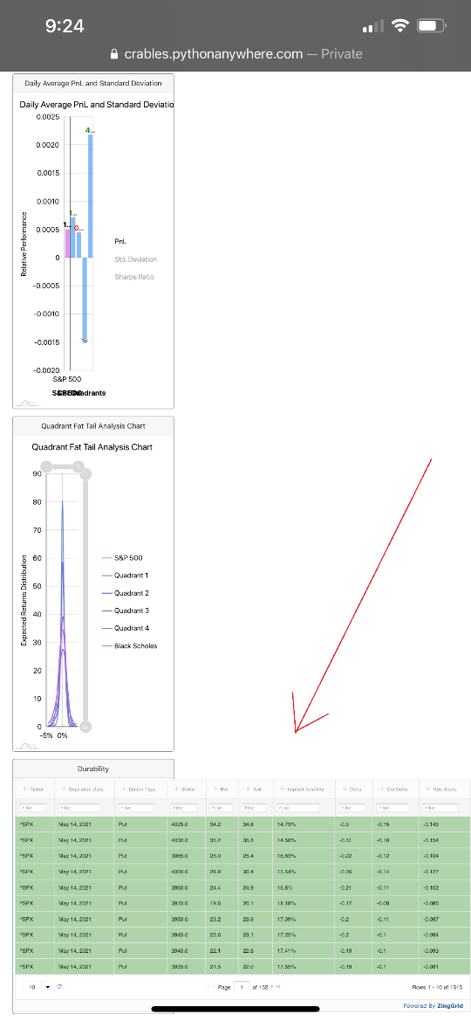

I did a quick search and found that zing grids supports mobile natively: <https://www.zinggrid.com/docs/features/mobile>

…so I thought it was strange that the table loaded like this on my mobile. Do you mind looking into how the page(s) can be configured so that they can easily adapt to a mobile format?

The above was the only technical issue. The rest of the list below are intended as enhancements to build upon the table and its functionality further:

1 – Increasing qty per page

Is it possible to increase the amount of options in the dropdown where a user can select the amount of rows to show? Or, to increase the size of the numbers (e.g., 10, 25, 50, etc)? A max of 20 is a bit constraining.

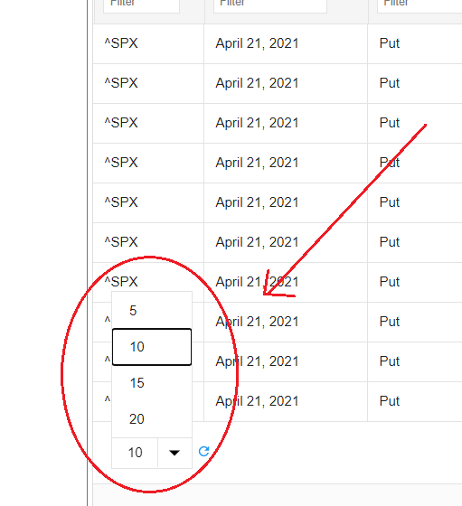

2 – Changing which piece of information trigger the highlight

I decided that it would be useful if all rows in the table have the Kde Score value. However, I would still like to only have a single row highlighted. This complicates things as we are currently deciding which row to highlight based on which row contains a kde score (but now they all do).

As an alternative, I created a new column in the table named “highlight_row”. Every value in this column is 0 except for the row that should be highlighted which has a value of 1. To my delight, the table actually used this value to decide which row to highlight automatically! (see below)

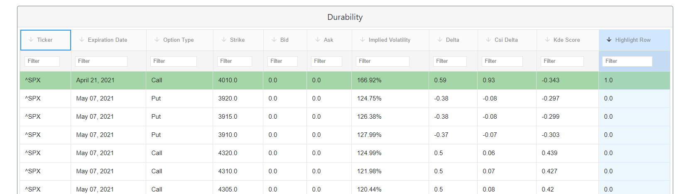

Is it possible to hide the Highlight Row column in the table so that its not displayed? The information is useful in the background to determine which row to highlight but other than that has no value to the user.

3 – Adding expandable row functionality

Do you think its possible to add expandable row functionality to the table where each section contains all the options for a single expiration date?

There are a few examples provided by zing in the following links:

<https://www.zinggrid.com/demos/web-component-grid-tree-data>

<https://www.zinggrid.com/demos/web-component-grid-collapsable-row>

The idea will be to provide more organization by grouping the 1000+ rows by expiration date. Similar to the example shown below:

